**ICRS Fellow Application Form**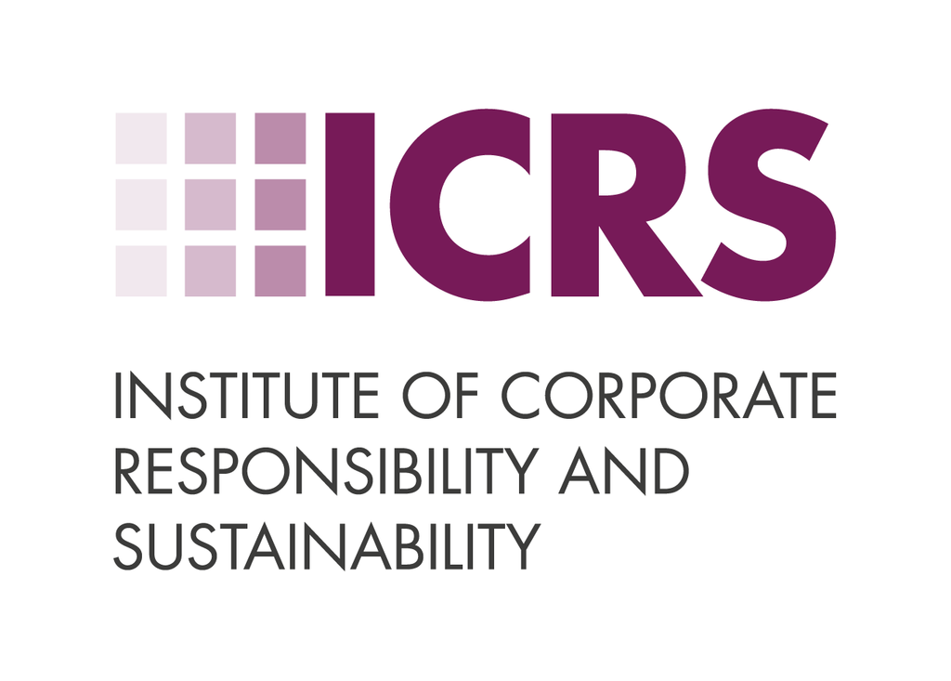

Declaration

By applying, I understand that the assessors’ decision regarding my eligibility for Fellowship of the Institute will be final.  
  
I have read and agree to abide by and promote the ICRS [Code of Conduct.](https://icrs.info/about/code-of-conduct)  
  
I confirm that all information supplied supporting my application for Fellowship is accurate and understand that misrepresentations may render the application invalid.  
  
I have read and understood the [terms and conditions](https://icrs.info/membership-terms-and-conditions/).  
  
I have read and agree to abide by the ICRS [Policy on Continuing Professional Development.](https://icrs.info/continuous-professional-development/)  
  
If successful, I agree to pay within 30 days of receiving the acceptance email and request to pay.  
  
My name and membership level will be published on the ICRS Membership Register.

Personal Details

**Name:**

**Current Employer:**

**Job Title:**

Career History

Eligible applicants must spend at least 75% of their current working time on CR&S and have at least five years' professional CR&S experience in the last eight years. If you are applying via the Academic Fast Track route, you must provide evidence of three years’ experience and details of a relevant Master’s Degree or PhD.

Please provide details on your current role and previous roles within this timeframe. You can provide a link to your LinkedIn profile or paste an up-to-date CV here.

CV Details:

LinkedIn Profile:

**Are you applying via the Academic Fast Track route?**

Yes or No (select one)

If no, please proceed to the next section.

If yes, please provide details of your qualification, including the course title, awarding institution and year of graduation/completion.

Please also explain how your Master’s course content/PhD subject matter has contributed to your application of the Guiding Principles and Competences in your current or previous role(s).

Demonstrating Guiding Principles

Please choose **three Guiding Principles** from the list below and explain how your achievements relate to the themes. You should respond to **four themes per Principle (a total of at least 12 responses**). You can see the full [ICRS Competency Framework here](https://icrs.info/competency-framework/).

Principle 1: Champion ethical behaviour

*Show personal integrity and promote ethical behaviour.*

Theme 6: Communications

Theme 5: Stakeholders

Theme 4: Strategy

Theme 2: Advocacy

Theme 3: Compliance

Theme 1: Awareness

Principle 2: Pursue positive social impact

*Look at business activity and impact through the social lens.*

Theme 6: Communications

Theme 5: Stakeholders

Theme 4: Strategy

Theme 2: Advocacy

Theme 3: Compliance

Theme 1: Awareness

Principle 3: Pursue positive environmental impact

*Look at business activity and impact through the environmental lens.*

Theme 6: Communications

Theme 5: Stakeholders

Theme 4: Strategy

Theme 2: Advocacy

Theme 3: Compliance

Theme 1: Awareness

Principle 4: Promote the development of sustainable products and services

*For new and existing products and services*

Theme 6: Communications

Theme 5: Stakeholders

Theme 4: Strategy

Theme 2: Advocacy

Theme 3: Compliance

Theme 1: Awareness

Demonstrating Competences

Please choose **four Core Competencies** from the list below and explain evidence of your achievements in each area. You can see the full [ICRS Competency Framework here](https://icrs.info/competency-framework/).

Competence 1: Engage with stakeholders

*Inspire internal and external stakeholders to engage with the organisation's CR&S goals; build relationships, and communicate effectively.*

Explain more:

Competence 2: Plan, develop strategy and manage projects

*Produce a robust CR&S system and influence strategy across the organisation to deliver CR&S goals*

Explain more:

Competence 3: Research and analyse

*Understand the organisation, its market and maturity as a responsible business, analysing risks and trends to determine materiality*

Explain more:

Competence 4: Influence and persuade

*Persuade leaders of the case for CR&S and challenge their thinking constructively*

*Work with them to manage change and embed sustainability across the organisation.*

Explain more:

Competence 5: Measure and report impact

*Set clear, measurable targets for CR&S*

*Report transparently on delivery, focusing on impact and outcomes; keep learning from experience.*

Explain more:

[ENDS]